Project by Group P1O:

* Joel Kong Boon Wei
* Leong Jun Wei
* Ong Jia Yi
* Joshua Goh Teck Khuang
* Shermaine Tan Ying Xuan
* Erin Zhou Chu Xiong
* Pang Jun Hong

Vitatrax

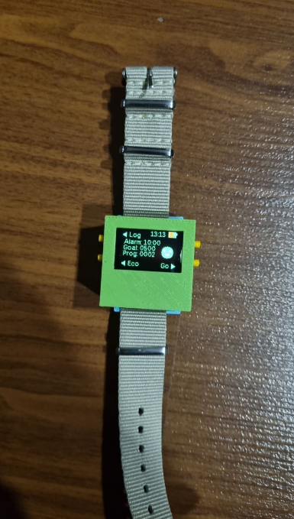

A tinycircuit watch, a unique wearable technology designed not only to track your daily steps but also to encourage users to contribute to environmental conservation efforts. Combining the functionality of a fitness tracker with an eco-friendly twist, the watch promotes physical activity for the benefit of both personal health and the environment.

Functions of Vitatrax:

* Step Tracking
* Stopwatch and Temperature reading
* Environmental Conservation
* Interactive Display
* Reward System
* Connectivity
* Game!

Connectivity:

Vitatrax takes your fitness journey to the next level by seamlessly syncing with a dedicated website – Vitatrax. This robust connectivity empowers users to effortlessly track their progress, set personalized goals, and become part of a dynamic community of eco-conscious individuals.

Accessing Vitatrax by connecting to Website:

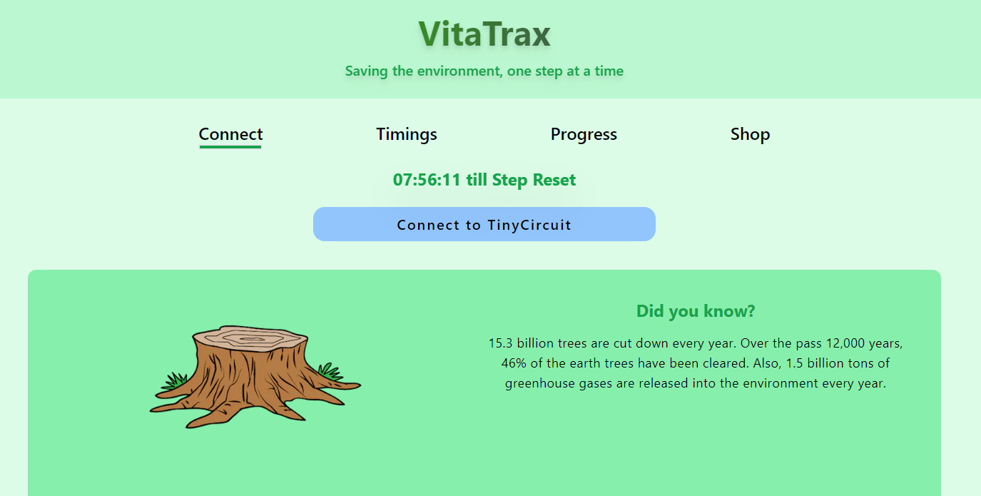 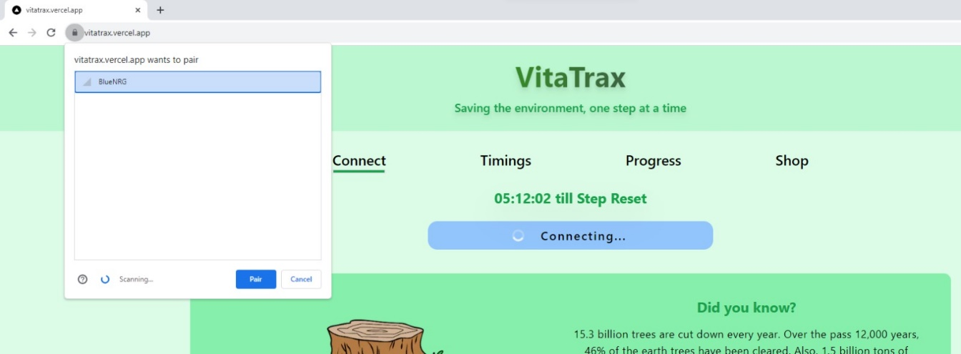

Engage with Vitatrax on a user-friendly website, providing unparalleled convenience for monitoring and control. This accessible platform ensures that users can connect with their watch's features from any device with Bluetooth connectivity.

Interactive Displays:

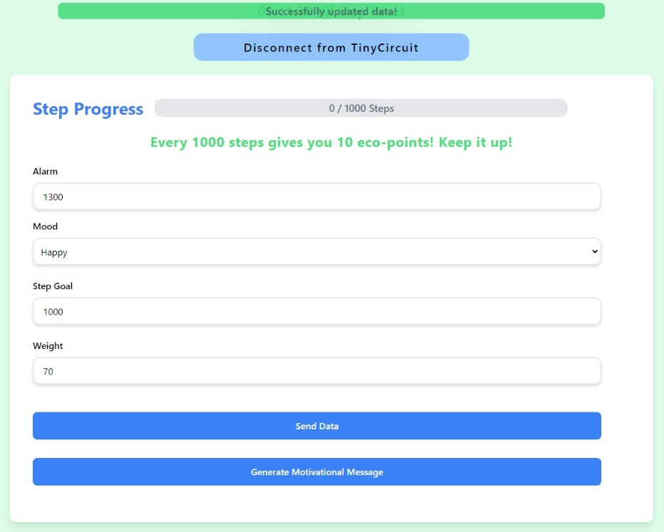

Set your own step goals:

Push yourself to the limits by setting your own daily goals and challenge yourself to complete it each day.

Mood Indicator:

Stay attuned to your emotional well-being with Vitatrax's Mood Indicator, offering an insightful snapshot of your current mood. Easily track your emotional trends and patterns for a holistic view of your mental health.

Set Alarm from Website:

Effortlessly manage your daily schedule by configuring alarms directly from the Vitatrax website. Simply shake to snooze the alarm when it goes off.

Step Tracking:



The watch employs an accelerometer to accurately measure and record your steps throughout the day. It serves as a personal fitness companion, motivating you to achieve your daily step goals. Daily step goals are set to encourage user to accumiliate points in order to exchange for rewards.

Stopwatch and temperature reading:



Boost your time management skills with Vitatrax's Stopwatch Function. Capture and save precise timings on the website, enabling accurate tracking of your activities and achievements. The watch features a progress bar indicating your current steps compared to your step goals, turning green upon completing your daily goal.

While monitoring your timing and progress, it also includes a temperature sensor that displays the ambient temperature. This feature helps you adjust your exercise intensity based on the environmental conditions.

Environmental Conservation/Interactive Display:

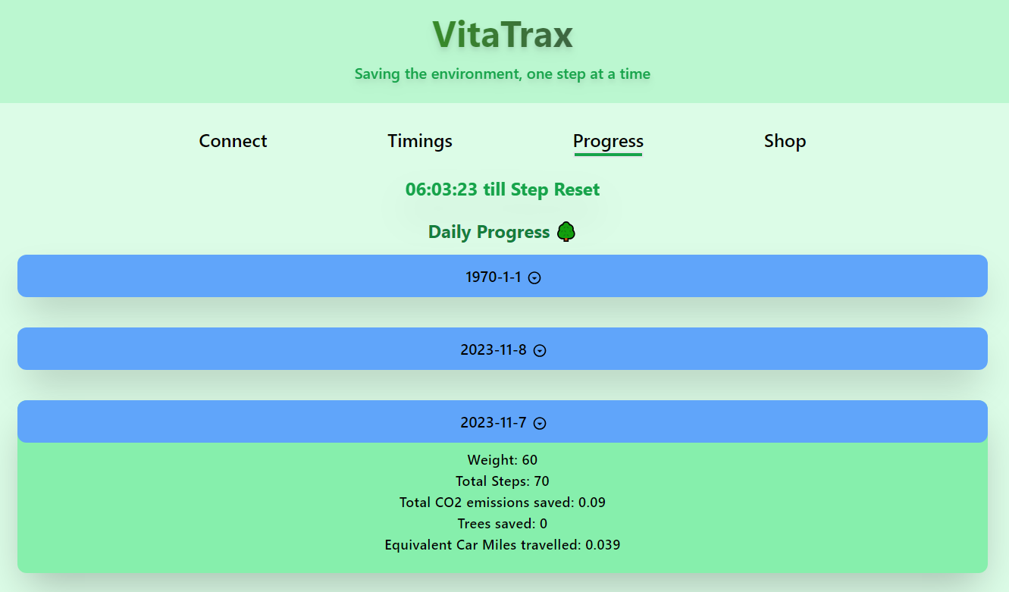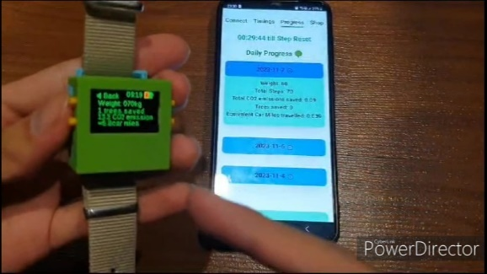

Beyond personal health, Vitatrax introduces an innovative concept where your steps contribute to environmental initiatives. A backend system calculates the environmental impact of each step, translating it into measurable contributions.

The user's contributions are visualized on the watch display, fostering a sense of accomplishment.

Reward System:



Users are incentivized to walk more through a rewards system. As you accumulate steps, you earn points or rewards that can be redeemed for various discounts.

Inbuilt Game of PONG:



Unwind and have fun with Vitatrax's inbuilt PONG game. Enjoy a classic gaming experience directly on your device, providing a delightful break from your routine.

Video of Vitatrax:

[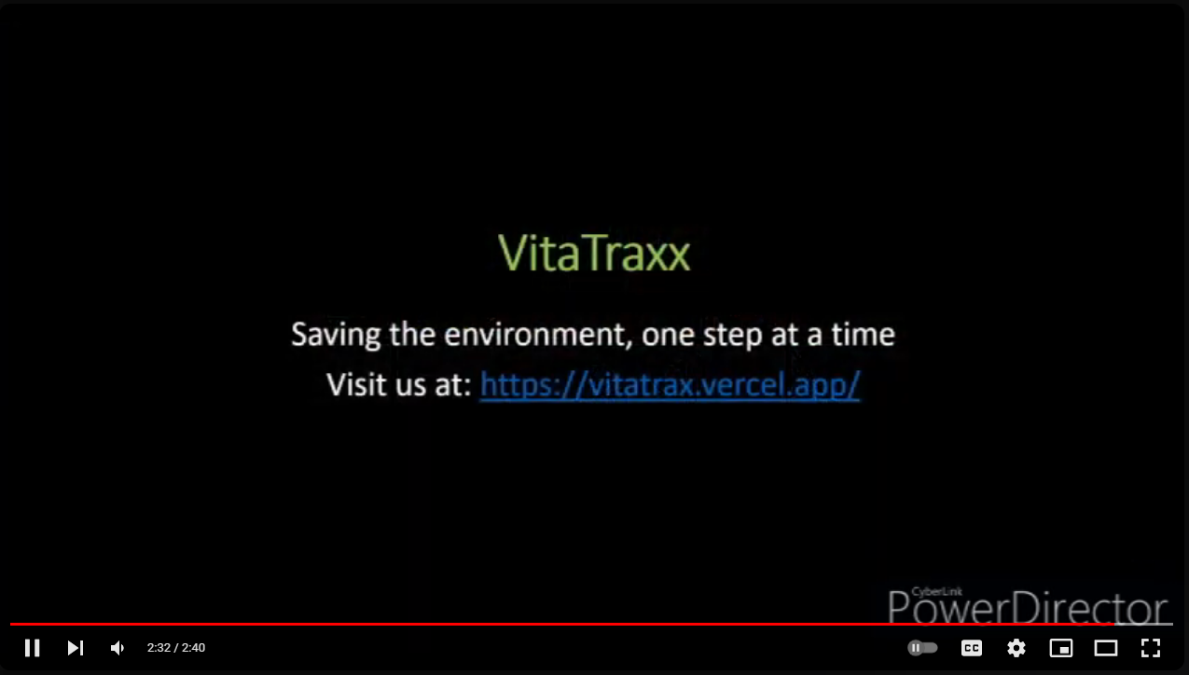](https://www.youtube.com/watch?v=UoslEajyh6s)

<https://www.youtube.com/watch?v=UoslEajyh6s>